Analysis of Layoff Statistics on during the period of

Covid - 19

Ankur Jain1, Mahika Agrawal2, Nikhil3

1,2,3School of Computing, VIT Bhopal University, Bhopal, India

***Abstract-***

Layoffs are becoming more frequent occurrences that stress those who find themselves in the firing line. Many businesses are forced to implement mass layoffs as a result of the coronavirus disease 2019 (COVID-19) pandemic, which is causing revenue losses throughout the world. Employees will surely find this stressful. However, studies have shown that uncertainty about potential job loss can have a range of detrimental psychological, behavioural, and physiological effects that are even worse than being actually laid off. To avoid all of the difficulties that can arise during analysis, one could use a data visualisation to drive conclusions from the layoff trend and make predictions. This data visualisation will help us better understand countries’ and companies’ layoff scenario.

***Keywords-*** Data Visualisation, Layoff, Industry, GDP, Country, Impact, Income, Employment, Laid

1. **INTRODUCTION**

Here is an extensive survey of empirical research conducted on layoff statistics published by Kaggle since 2020-2022 in the form of visualization using Tableau. It is appropriate that during the past few decades, scholars have worked to understand job uncertainty and its negative repercussions. The amount of research that has resulted has mostly concentrated on identifying the effects of work insecurity, such as job satisfaction, safety practises, psychological stress, and physical health. It is obvious that job uncertainty has high costs, which only seem to increase with duration of exposure. Therefore, it is important for academics to pinpoint the elements that can contribute to lowering persistent or rising job insecurity.

**a) Application:** Understanding of the root causes that must have led to massive layoffs across variety of sectors.

**b) Focus and purpose:** After reading several study papers, it was concluded that it was crucial to examine the reasons as to what led to the massive layoffs in the span of Covid-19 and the impact of it on Country’s GDP and overall health of laid-off employees. On the basis of an understanding of the trends in each country and each industry, it becomes simpler to analyse and make the appropriate judgments.

**c) Broad Problem:** Growing from a very tiny base in the fiercely competitive global market of today is extremely difficult. The harm to the employment market appears to be severe and long-lasting as the coronavirus pandemic continues to develop. Many managers are experiencing underlying concern about their own positions in addition to the stress and anguish associated with having to let go of a significant proportion of their employees. How can you deal with your sentiments of regret and sadness even if firing staff is the only way to keep the business afloat? When it is not possible to meet in person, how should the news be delivered? What should you say to your surviving employees? And what can you do to control your own future-related fear?

**d) The Literature review /previous work:** Based on their context of earlier studies, they propose measures that could strengthen relationships of mutual respect and trust between employees and managers, increase chances for participation in decision-making, and improve communication with staff members about current changes. Employees may, in fact, seek to interpersonal connections and organisational communication as sources of stability and support to help them deal with uncertainty when a job loss is imminent.

**e) Current state of the problem:** The impact of Covid-19 has impacted every industry contributing to the world’s economy. While governments have started to respond to the ailment of laid off employees, their capacity is tightly constrained.

**f) Motivation:** Physical, economic, and environmental factors all affect company’s downsizing. People continuously look for potential environmental cues that could suggest how threatened they are in times of change and uncertainty. Several additional metrics can be used to measure a company's progress. Studying these potential reasons helps us better understand the laying off criteria of various companies.

**g) Novelty:** The project is unique as it uses the Tableau tool to visualize the data and uses real time situations to understand better.

**h) Advantages:**

* Analysis of trends in layoffs.
* Potential layoff identification
* New insights can lead to ideas and innovations
* Predicting layoffs that might happen in future.

**i) Disadvantages:**

* The analysis might be somewhat constrained by the dataset.

# II. PROBLEM FORMULATION

1. ***Modelling of Data***

The aim of this project is to analyse the data of various companies, countries, industries and to find out the relationship between the various layoff trends. We used the data visualisation tool Tableau.

1. ***Modelling Various Research Sectors***

The project is divided into various parts. Keeping countries and companies spread worldwide, the various industries include Education, Health, Economy, Environment, Media, Agriculture, Employment etc.

1. ***Various Problem Statements***

The following problem statements were examined during our analysis:

1. Which country has the maximum and the minimum layoff?

2. Keeping in mind the timeline of Covid-19, which year went through the maximum layoffs?

3. Which industry was impacted the most by layoffs?

4. What is the employment ratio in each country?

5. How is Countries’ layoff trend over the course of Covid-19?

6. Which country houses the maximum number of companies and why?

7. What is the Impact of layoff on laid off employees?

**III. METHODOLOGY**

Implementation: The first step in the methodology followed included data collection. I used the [Layoffs dataset](https://www.kaggle.com/datasets/swaptr/layoffs-2022) from Kaggle. The dataset contains 9 columns mentioning the company, location, industry, number of total laid off, percent of total laid off, date, stage of company, the funds raised by each company and the countries they belong to from 2020 to 2022. The dataset was cleaned and pre-processed to remove null values and irrelevant columns.

So we have used pandas framework to clean the data, the various steps involved in cleaning the data are:

1. Removing the null values

2. Removing the irrelevant columns

3. Removing the irrelevant rows

4. Removing the duplicate values

5. Keeping records of the most recent data available

The second step was to perform exploratory data analysis on the dataset. We used various visualizations to understand the data and its distribution. We also used various statistical tests to understand the relationship between the variables.

**IV. RESULT**

The various analysis performed on the dataset are as follows:

* **Industry-wise Layoff Percentage**

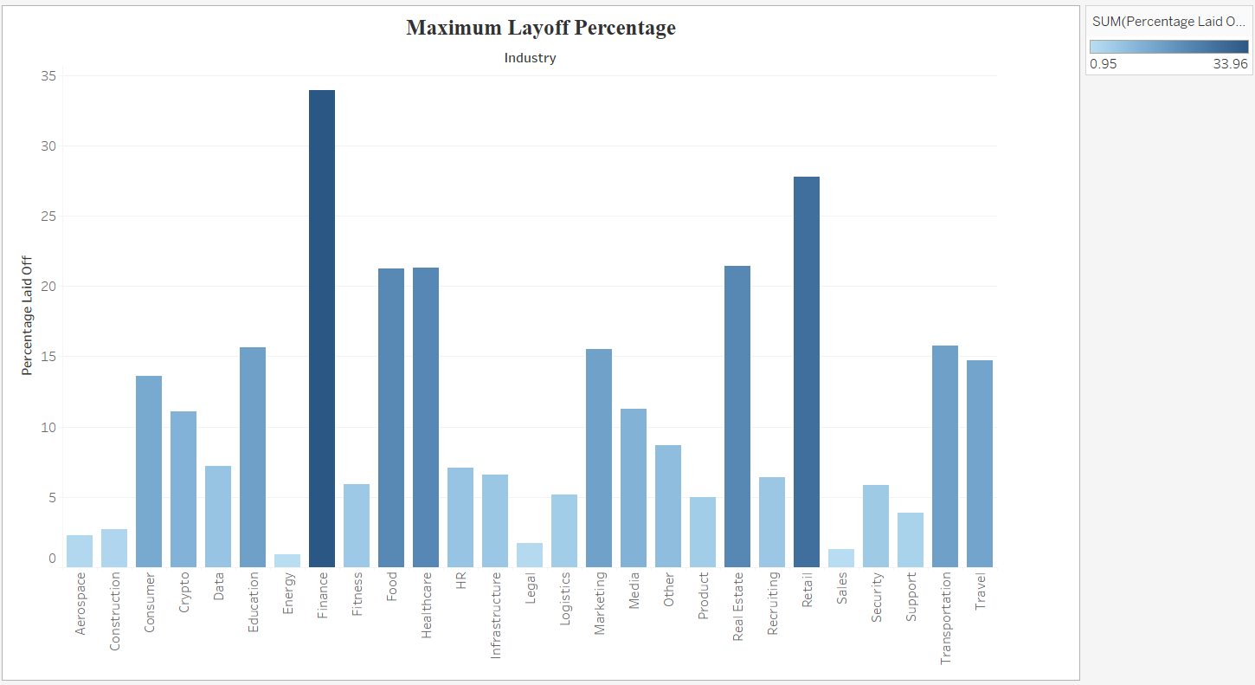

Layoff anxiety is real, and it can significantly impact your well-being. Studies have shown that job insecurity can negatively impact your concentration and motivation and lead to mental health issues, such as anxiety and depression. The following visualization on the screen shows the Industry wise trends in Layoffs. From this we can conclude that the finance industry along with Retail industry have seen the maximum layoffs and comparatively Energy, sales, Legal and aerospace industries have had minimum layoff

* **Country-wise Total Laid off**

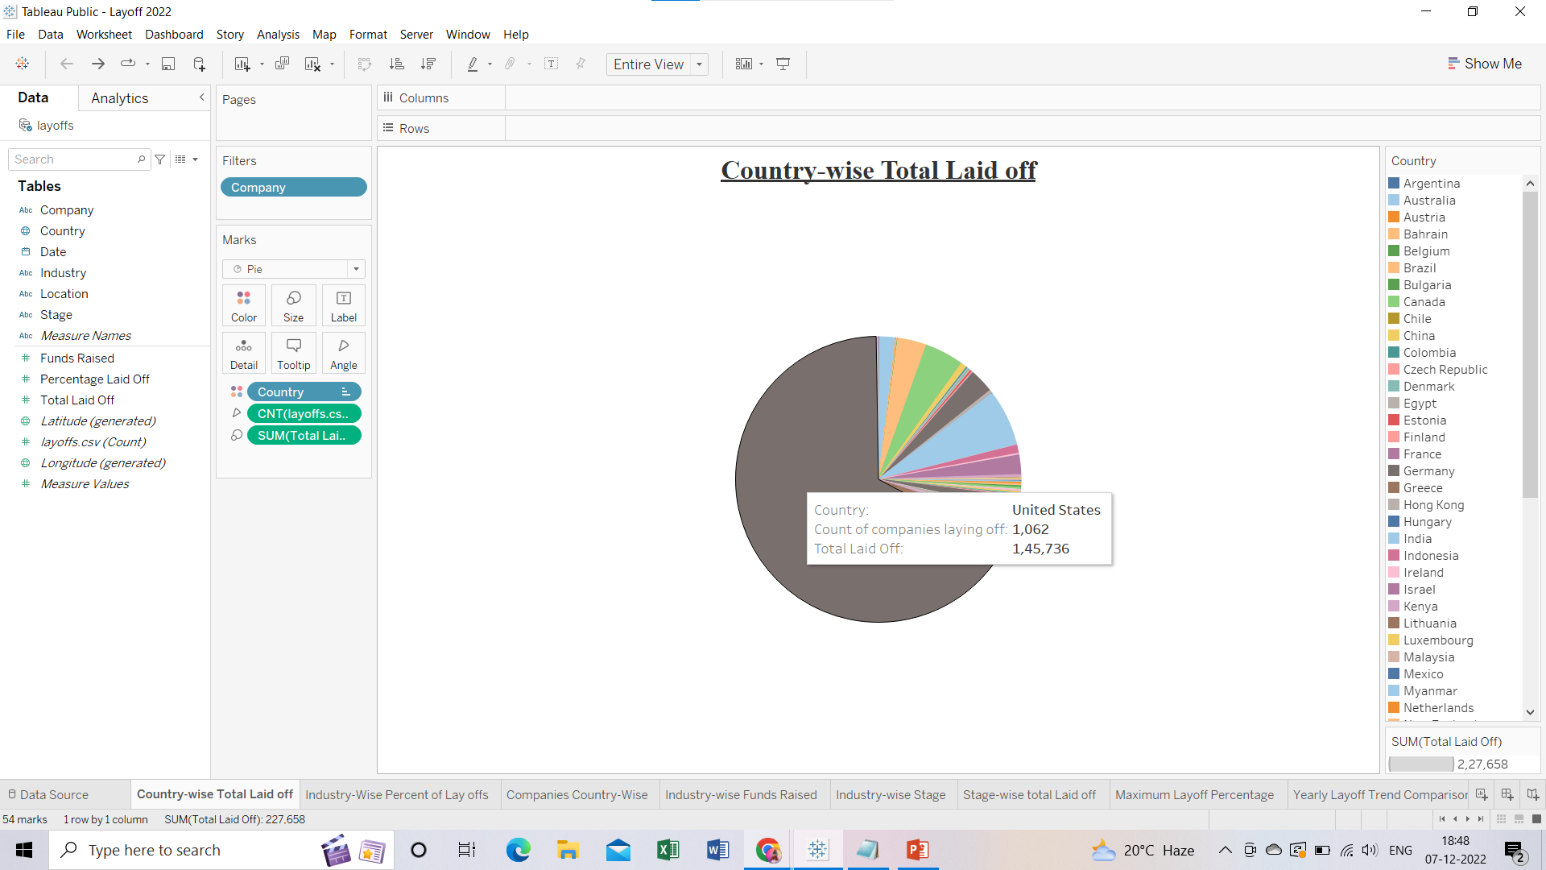The pie chart shows that US has the maximum number of Layoffs. Around 1062 companies have laid off 1,45,736 employees and it still hasn’t stopped. Corporate America is drastically reducing its workforce as part of its restructuring efforts to prepare for a probable economic downturn brought on by the U.S. Federal Reserve's fight against inflation and the war in Ukraine.

* 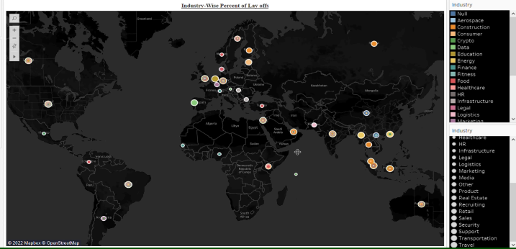**Industry wise Layoff Percentage**
* 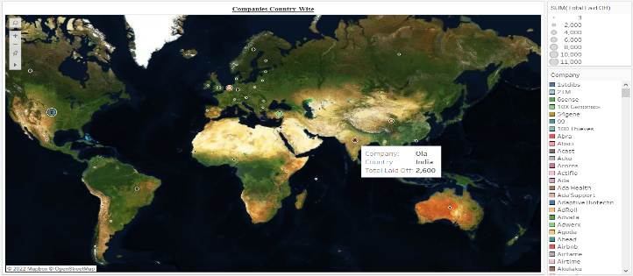**Companies Country-wise**

Location plays a huge role in attracting and retaining the best employees, many of whom keep a close eye on where they're based in order to optimize work-life balance. Good location decisions can significantly boost a company's long-term performance. Poor ones can cost millions in lost talent, productivity and capital.

* 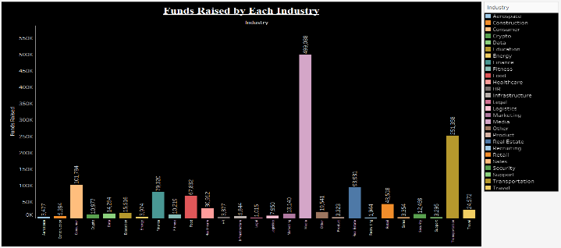**Funds Raised by each Industry**

The main sources of funding are retained earnings, debt capital, and equity capital. Companies use retained earnings from business operations to expand or distribute dividends to their shareholders. Businesses raise funds by borrowing debt privately from a bank or by going public (issuing debt securities). The following bar graph shows that the maximum amount of funds have been raised by the **Media** industry

* **Yearly Layoff Trend Comparison**

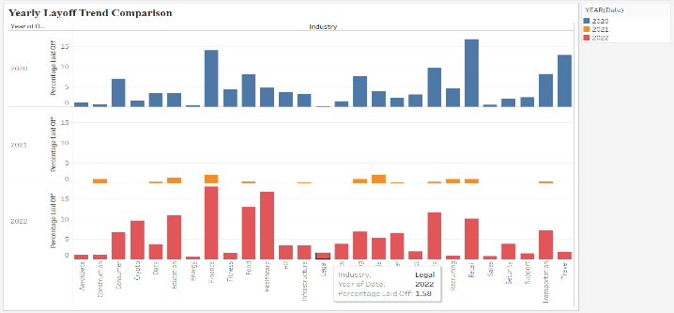The bar graph shows the year wise trends in layoffs in each industry. From the bar graph we can derive that 2022 has gone through the maximum number of layoffs irrespective of the industry

* **Year wise Country Trend**

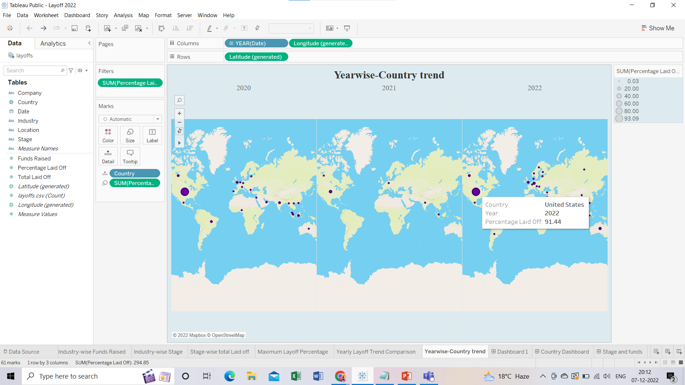

This map is the year wise trend of Companies and their respective lay-off percentage over the course of 3 years from 2020 to 2022

**V. CONCLUSION**

Future work: Future additions of more graphs for greater analysis can be made as we learn new ideas. This research could be applied to resolve issues related to layoffs and understand the mental state of a person, country and impact on GDP after layoff.

**VI. ACKNOWLEDGEMENTS**

We would like to thank our mentor Dr. Ankur Jain for his guidance and support throughout the project. This project made us understand the importance of data analysis and how it can be used to solve real-world problems.

***REFERENCES***

1. <https://www.kaggle.com/datasets/swaptr/layoffs-2022>
2. [https://public.tableau.com/app/profile/mahika.agrawal1593/viz/Layoff_2022_v01/CountryDashboard](https://public.tableau.com/app/profile/mahika.agrawal1593/viz/Layoff_2022_v03/YearlyDashboard)
3. [https://public.tableau.com/app/profile/mahika.agrawal1593/viz/Layoff_2022_v02/Stageandfunds](https://public.tableau.com/app/profile/mahika.agrawal1593/viz/Layoff_2022_v03/YearlyDashboard)
4. <https://public.tableau.com/app/profile/mahika.agrawal1593/viz/Layoff_2022_v03/YearlyDashboard>
5. <https://piktochart.com/blog/types-of-graphs/>